Name :

Student number :
Email address :
Age :

Gender:
- Man
- Woman

Highest completed prior education:
- MBO
- HAVO
- VWO
- HBO
- WO
- Otherwise

You are now starting the first part. This part consists of 8 questions.
Read each question carefully and then choose the best option. Complete this test in full.
Now do the assignments.

Assignment 1 .

Below you will find two statements. Assume that they are true!

Proposition 1. Nuts can be eaten.
Proposition 2. Some rocks cannot be eaten.

What can you conclude about rocks based on these two statements?

- Some rocks can be eaten.
- Some rocks are nuts.
- Some rocks are not nuts.
- No correct conclusion possible.

How much effort did it take you to answer this question?

- Very little effort
- Very little effort
- Little effort
- Relatively little effort
- Not a little and not a lot of effort
- Quite a lot of effort
- A lot of effort
- A lot of effort
- A lot of effort

Assignment 2.

Each of the blocks below has a letter on one side and a number on the other. The rule is " if the letter Y is on the front, then the number 2 is on the back . "
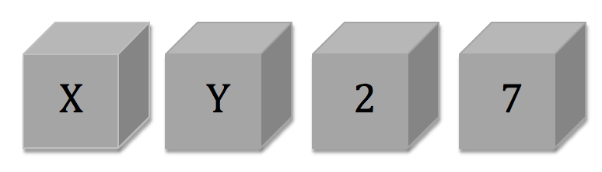Which blocks do you turn over to see if the rule is being broken?
- X and 2.
- X and 7.
- Y and 2.
- Y and 7.

How much effort did it take you to answer this question?

- Very little effort
- Very little effort
- Little effort
- Relatively little effort
- Not a little and not a lot of effort
- Quite a lot of effort
- A lot of effort
- A lot of effort
- A lot of effort

Assignment 3 .

The Jacobs family has decided to buy a new car, choosing a solid and safe German car—either an Audi or a BMW. They want to do some research before deciding. They receive a copy of a report in which experts state that both cars are mechanically sound, although the Audi performs better in some areas. Consumer research shows that Audi owners report fewer mechanical defects than BMW owners. The Jacobs family is about to start negotiating with the Audi dealer. Suddenly, they remember two friends, one with a BMW and one with an Audi. They call them. The BMW owner reported a few minor issues, but nothing major. The Audi owner nearly exploded on the phone: "First, the fuel injection computer broke, resulting in €800 in damage, then problems with the steering, and then another problem with the transmission and clutch. After three years and significant repair costs, I finally got rid of the Audi."

What is the best thing for the Jacobs family to do?

- Maybe they would be better off buying the BMW.
- They would definitely be better off buying the BMW.
- Maybe they would be better off buying the Audi.
- They would definitely be better off buying the Audi.

How much effort did it take you to answer this question?

- Very little effort
- Very little effort
- Little effort
- Relatively little effort
- Not a little and not a lot of effort
- Quite a lot of effort
- A lot of effort
- A lot of effort
- A lot of effort

Assignment 4 .

Below you will find two statements. Assume that they are true!

Proposition 1. All living things need water.
Proposition 2. Roses need water.

What can you conclude about roses based on these two statements?

- All roses are living things.
- Some roses are living things.
- Roses are not living things.
- No correct conclusion possible.

How much effort did it take you to answer this question?

- Very little effort
- Very little effort
- Little effort
- Relatively little effort
- Not a little and not a lot of effort
- Quite a lot of effort
- A lot of effort
- A lot of effort
- A lot of effort

Assignment 5.

Karin is a young woman, 31 years old, single, spontaneous, and a philosophy graduate . During her studies, she was socially active, concerned about declining tolerance in society, and participated in demonstrations against the construction of new nuclear power plants. Which option is most likely?

- Karin works at a bank.
- Karin works at a bank and is active in the environmental movement.
- Karin works at a bank and is active for a local political party.
- Karin works at a bank and is active in the environmental movement and for a local political party.

How much effort did it take you to answer this question?

- Very little effort
- Very little effort
- Little effort
- Relatively little effort
- Not a little and not a lot of effort
- Quite a lot of effort
- A lot of effort
- A lot of effort
- A lot of effort

Assignment 6 .

A study of 1,000 people involves 975 women and 25 men. Robin is a randomly selected participant. Robin is 23 years old, has a mechanical engineering degree, enjoys going out with friends, enjoys a beer, and is a fan of hard rock music. What are the odds that Robin is male?

- More than 75%
- 50%
- 30%
- Less than 3%

Assignment 7 .

Each of the blocks below shows a specific behavior (drinking beer or cola) on one side and an age (15 or 18 years old) on the other side.
The rules are “if a person drinks beer then he is 18 years old”.
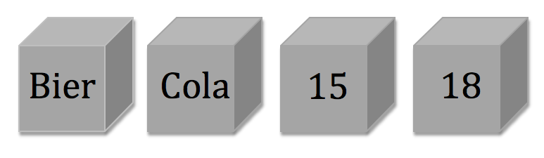

Which blocks do you turn over to see if the rule is being broken?

- Beer and 15.
- Beer and 18.
- Coke and 15.
- Coke and 18.

How much effort did it take you to answer this question?

- Very little effort
- Very little effort
- Little effort
- Relatively little effort
- Not a little and not a lot of effort
- Quite a lot of effort
- A lot of effort
- A lot of effort
- A lot of effort

Assignment 8 .

A Public Administration instructor has found that when students discuss the material in small groups during lectures, they're more likely to perform better on the exam. Therefore, the instructor regularly interrupts the lecture to pose a question to students that they can discuss together. The instructor expects positive results from this. Which of the following options do you think is most likely to succeed?

- the students score at least 0.1 point higher on the exam.
- the students score at least 0.3 points higher on the exam.
- the students score at least 0.7 points higher on the exam.
- the students score at least 1.0 point higher on the exam.

How much effort did it take you to answer this question?

- Very little effort
- Very little effort
- Little effort
- Relatively little effort
- Not a little and not a lot of effort
- Quite a lot of effort
- A lot of effort
- A lot of effort
- A lot of effort

